Insurance Premium Summary System

Objective
Develop a .NET Console Application that captures basic insurance policy data for a small set of customers, processes the data using value types and strings, and displays a formatted insurance summary report.

Business Scenario
An insurance company wants to review annual premium details of its customers for quick verification.

Data Design (Must Follow)
Use only these two arrays:
- string[] policyHolderNames
- decimal[] annualPremiums
Other values must be stored using individual variables, not arrays.

Functional Requirements
1. Input
- Accept details for 5 policyholders
- For each policyholder:
  - Name (string)
  - Annual premium amount (decimal)
- Validation:
  - Name cannot be empty
  - Premium must be greater than 0
- the user should be required to re-enter the value until it is correct.

2. Processing (Value Types)
Using loops and value-type variables, calculate:
- Total premium amount
- Average premium
- Highest premium
- Lowest premium

3. String Operations
- Display all policyholder names in uppercase
- Display premium category:
  - "LOW" → Premium < 10,000
  - "MEDIUM" → Premium between 10,000 and 25,000
  - "HIGH" → Premium > 25,000
(Category must be decided using if/else, not arrays.)

4. Formatted Output
Display the report in the following format (ignore colors):

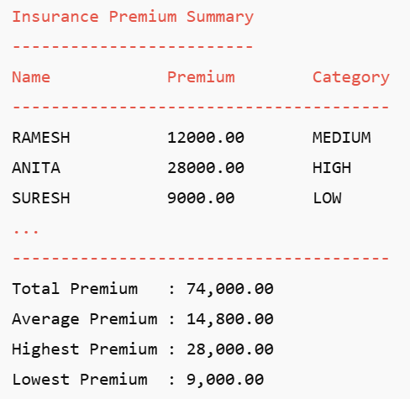
Formatting Rules:
- Align columns properly
- Display premium values with two decimal places
- Use clear headings

